1. Install Jupyter notebook and run the first program and share the screenshot of the output.

**Solution:**

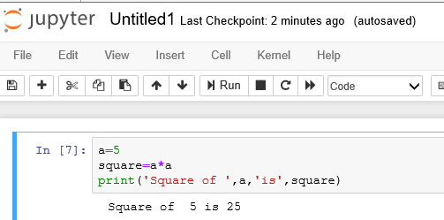

**2**. Write a program which will find all such numbers which are divisible by 7 but are not a

multiple of 5, between 2000 and 3200 (both included). The numbers obtained should be printed

in a comma-separated sequence on a single line.

**Solution:**

start=2000

end=3200

for i in range(start,end+1,1):

if((i%7==0) and (i%5!=0)):

print(i,end=',')

else:

continue

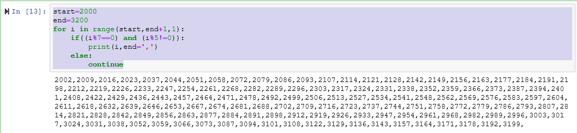

**3**. Write a Python program to accept the user's first and last name and then getting them printed

in the reverse order with a space between first name and last name.

**Solution:**

FirstName='Pankaj'

LastName='Sarkar'

Name=LastName+' '+FirstName

print(Name)

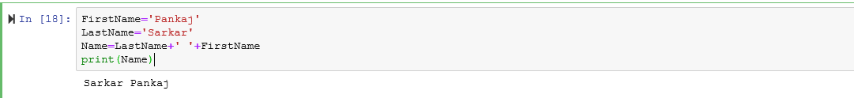

**4**. Write a Python program to find the volume of a sphere with diameter 12 cm.

Formula: V=4/3 * π * r^3

**Solution:**

import math

dia=12

rad=dia/2

vol=(4/3*math.pi*(rad**3))

print(vol)

